GLACIATIONS -- cold and warm periods on Earth
Thousands of years before present, BP, also called, years ago.
1200 - 800 Pre-Pastonian Glacial cold 400,000 years ^ Lucy 3700K
800 - 680 Pastonian Interglacial warm 120,000 years
680 - 620 Gunz/Nebraskan Glacial cold 40,000
620 - 455 Gunz-Midlel Interglacials warm 165,000
455 -380/300 Mindel / Kansan Glacial cold 155,000
300/380 -200 Mindel-Riss Interglacial warm 100,000
200 - 130 Riss/ Illinoinan glacial cold 70,000 Eve 170K
130 - 110 Riss-Wurm Internglacial warm 20,000
110 - 12 Wurm / Wisconsin glacial cold 98,000 Adam 60K
12 - 0 Holocene/Present Interglacial warm 12,000 with how much to go? 10 years or 80Kyr?

Other
3,000,000 Panama closed ocean exchange.
20,000 last glacial maximum (dry, lowest sea level)
Ice extended to Missouri and Ohio Rivers to NYC
Borneo Sumatra, Bali and Palawan were connected to Asia.
Rest of the Philippines were one island.
Australia and New Guinea were connected forming Sahulland.

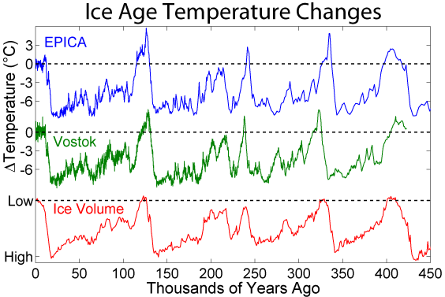 | Beringia -- Much of the Bering and Chukchi Seas were dry land 1,000 miles (1,600 km) north to south. Occurred many times in history allowing animal species to cross between old and new worlds. Horses, for instance, originated in N. America, died out and were returned by the Conquistadors. Existed both in the glaciations that occurred before 35,000 BP and during the more recent period 22,000-7,000 years Before Present. The strait re-opened about 15,500 BP and by c. 6000 BP the coastlines had assumed approximately their present configurations.

Medieval Warm Period -- a time of warm weather around 800-1300 AD during the European Middle Age.

Little Ice Age: 1300 - 1850.
Beginning is indicated by any of several dates ranging over 400 years::
* 1250 for when Atlantic pack ice began to grow
* 1300 for when warm summers stopped being dependable in Northern Europe
* 1315 for the rains and Great Famine of 1315-1317
* 1550 for theorized beginning of worldwide glacial expansion
* 1650 for the first climatic minimum
There is a consensus that the Little Ice Age ended in the mid-19th century.

http://www.manorweb.com/creative/2009/pics.html -- more pictures

